Project 3 Report
Fatima Davila
CIVI 202
March 31, 2026
Table of Contents
Project 3 Report 1
Methods: 1
Results and Discussion: 4
References: 4

Introduction:
Transportation is a very important factor in the running of society. In this project we will be analyzing data from two different sources, which are the National Household Travel Survey (NHTS) and the Next Generation Simulation (NGSIM) Data. The purpose of this project is to provide the Federal Highway Administration (FHWA) with readable graphs that hold valuable information from the traffic data inside the NHTS csv and the NGSIM csv. Another goal is creating a simulation using IDM so that the client can better understand simulated data compared to real life data.

Methods:
The variables our team selected were the fuel types used and the number of them in use. We chose this because of how heavy a topic gasoline is on the news as of late with the spike in gas prices we wanted to see if there were more electric cars in use. We also used variables for Urban and Rural vehicles to see if there was a trend of there being new cars in rural areas as opposed to urban areas. We also decided to use age to compare the difference in ages among different models of cars and to pay attention to those trends. Speed, acceleration, time, and position are all very important factors that come into play when studying transportation, so we decided to use those as well.
To create these charts the packages for plotting graphs in python must be imported into the code first. Following that the data provided by the client must be loaded to be used for analysis. After that, functions for variables that will be plotted must be defined and then using python or seaborn plots can be made and edited to offer a clear image of what the data is describing. To make a bar plot in seaborn we set the parameters for “kind” to be “bar” the output for this can be seen in figure 1. To create the histogram seen in figure 2 we used the python appendage of “.hist” and set the parameters to be equal to 10 to have a good sight of what we were analyzing. We also used the parameter of “alpha” to control the transparency of the variables to help with presenting the information. We used pythonagain to create the box plot with the appendage “.boxplot” added to the NHTS data. The output for this can be seen in figure 3. We used a line plot to create the time-series graphs seen in figure 4 and 5.
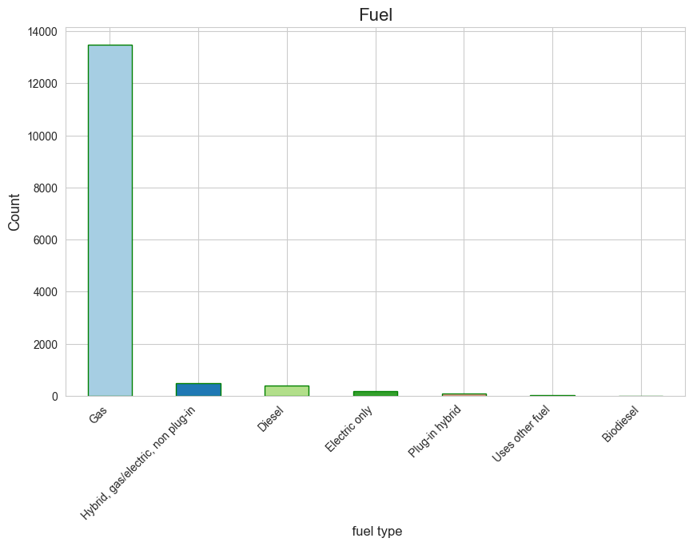
Figure 1 demonstrates in a bar graph the number of cars per fuel type
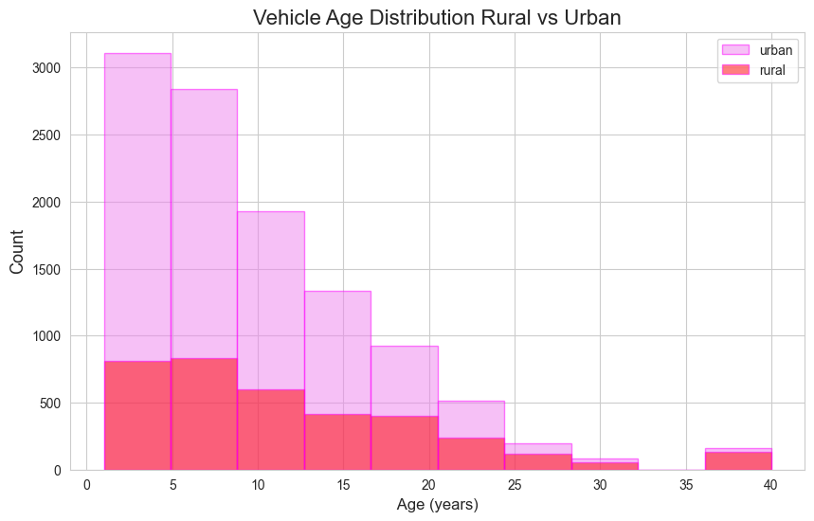
Figure 2 displays a histogram comparing the ages of vehicles that are in urban vs rural areas
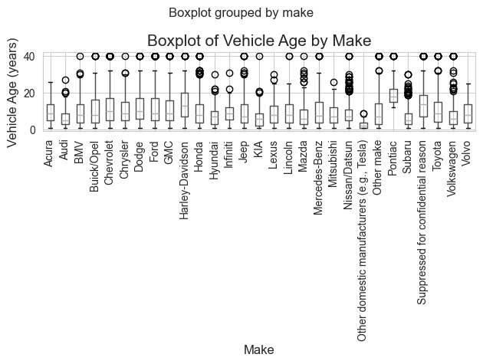
Figure 3 displays a box plot by make of vehicle
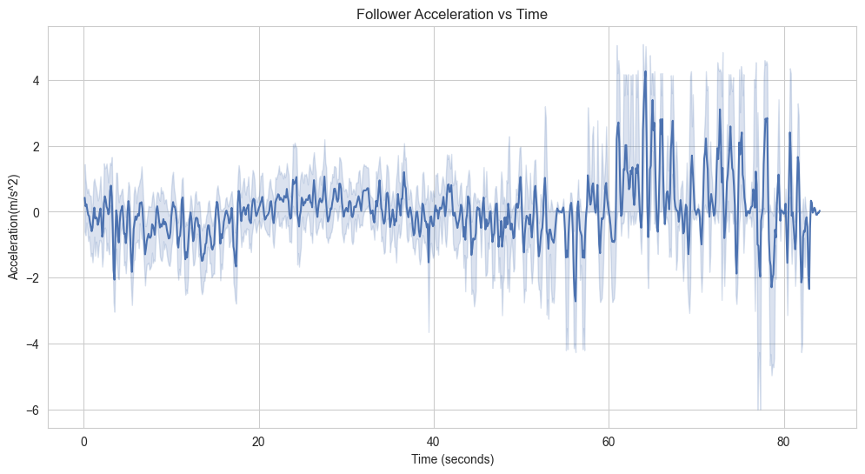Figure 4 shows time-series graph 1
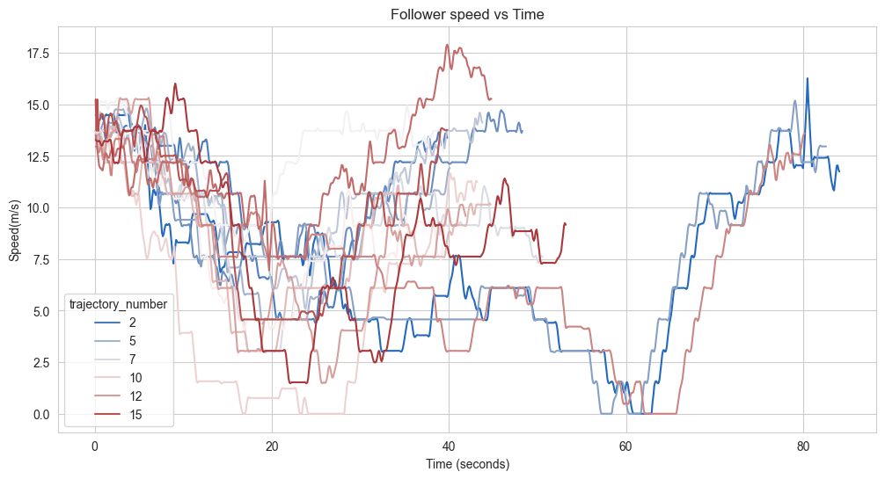
Figure 5 shows time-series plot 2
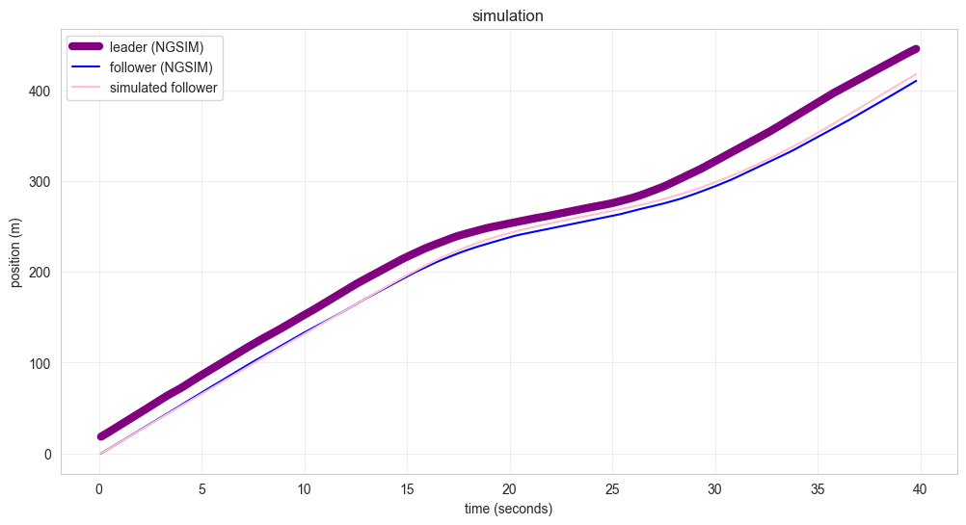
Figure 6 shows the output of the simulation done by the IDM program

Results and Discussion:
In figure 1, a key finding was that most common used fuel type was gas, this is important to transportation in that developers need to ensure that there are enough gas stations to meet that need. In figure 2, shows that urban areas have much more newer vehicles than rural areas. The boxplot shown in figure 3 shows that majority of cars are under 20 years old. This information is important because the age of a car determines the mobility of someone to get around town or in a big city. The time series plot in figure 4 shows follower acceleration increases with time. This is important because it is information on traffic flow. The plot seen in figure 6 shows that follower (NGSIM) and simulated follower kept about the same pace behind the leader speed. In transportation this means that simulated variables can be trusted.

References:

National Household Travel Survey (NHTS) Data (2026) https://uofnebraska-my.sharepoint.com/:x:/g/personal/97210959_nebraska_edu/IQCttjCGzGakSLdPmzOItrwKAUuCYfvfVtvaGyve0y_3RBw?e=bOFbFN
Next Generation Simulation (NGSIM) DATA(2026) https://uofnebraska-my.sharepoint.com/:x:/g/personal/97210959_nebraska_edu/IQA6TF3l-4MiS5BE7NyooIbrAfP4R258Z1dcDJ0qxL568MY?e=BdBPrf

